7 Tips to Help You Care for Your Allergic Pet
Drs. Foster & Smith Educational Staff
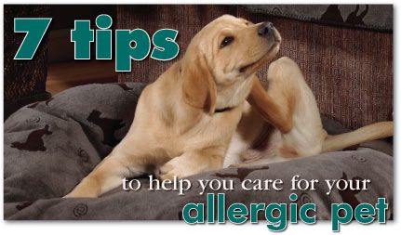
Although not usually life threatening, the symptoms of allergies can make your pet miserable.
If you and your veterinarian have determined that your pet has an allergy, you can do many things at home to ensure your allergic pet is comfortable. Remember that pets' skin is prone to injury from scratching. Try to minimize reasons that your pet might scratch or chew at himself.
Simply making sure your pet is very clean and is fed a premium diet with proper supplementation can go a long way towards helping to eliminate or lessen his discomfort.
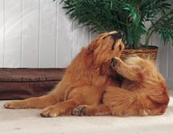
- Use glass or stainless steel pet dishes and keep them clean.
- Wash your pet's bedding in hypoallergenic detergents.
- Bathe your pet with shampoos to remove debris and build-up as well as to relieve some of the symptoms associated with allergies. Some appropriate shampoos would be:
  - Hypo-Allergenic Shampoo for super-sensitive allergy-prone skin.
  - Oatmeal Shampoo to exfoliate dry skin.
  - Itch Stop Shampoo to soothe irritating itching.
  - Soothing Shampoo if your pet has hot spots or other secondary bacterial infections.
  - Medicated Shampoo if your pet has secondary oily seborrhea.

- Use our Itch Stop products in conjunction with Soothing Mist® or Soothing Pads® to relieve itchy, inflamed skin.
- Gently brush haircoat regularly to distribute oils and to make sure your pet has no mats or tangles that can further irritate skin.
- Although this can be tough, try to minimize the exposure of your pet to the suspected (or confirmed) allergen.
- Supplement with an Omega-3 fatty acid product (like Healthy Coat Omega-3 Gel Caps). Combine with Healthy Coat Allergy Tabs for maximum effectiveness.
The above tips combined with the allergy chart below should help your uncomfortable allergic pet reach a comfort level you both can live with.
If your pet is allergic to:
House dust/dust mites  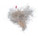  - Vacuum regularly and keep your pet out of the room when vacuuming  - Put plastic cover on pet's bed  - Wash bedding in very hot water  - Avoid stuffed toys  - Don't let pet on furniture or carpet  - Run air conditioner when it's hot | Pollens    - Keep pet inside when mowing  - Rinse dog after walking in high grass  - Avoid walking dog on grass  - Keep pet indoors when pollen count is high  - Use air conditioners or an air filter
Molds  - Keep pet out of basement  - Keep pet food fresh  - Clean/disinfect humidifiers and air filters  - Avoid large numbers of houseplants  - Change furnace/air-conditioning filters frequently | Fleas  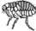  - Vacuum regularly and seal and dispose of the bag each time  - Use a topical flea preventive that repels and kills fleas before they bite the allergic pet  - Make sure yard and household are flea-free  - Use flea prevention on other household pets
Smoke
- Do not smoke or allow others to smoke around pet
- If this is impossible and there is a smoker in the house, make sure that the house is aired out frequently
- Use Hepa filters in the furnace and/or air conditioner

